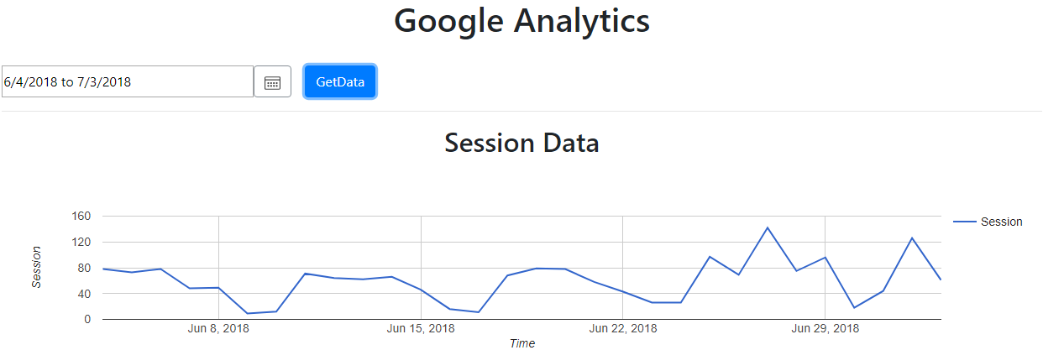Total Sessions =

Lead Testing Press Release on NYCHA

Hot Weather Health Advisory



Enter Analytics Notes

|  |  |
| --- | --- |
| Top Ten most popular indicators | Top 10 Referring Sites |
| Networks– All | Networks– Education |
| CDC Popular Content | |

**Analytics annotation function**: we’ll add a table to the database that will allow Nancy to add the following information, by pressing the blue button at the top of the screen:

|  |  |  |  |
| --- | --- | --- | --- |
| **Note Title** | **Note Description** | **Date of note** | **User** |
| Lead News from City | The city revealed the extent of childhood lead poisoning in NYCHA housing | 7/2/2018 | Nancy Jeffery |
| Hot Weather Health Advisory | Press release with portal link | 6/28/2018 | Nancy Jeffery |

These notes will be flagged on the daily use statistics graph.

CRUD operations page:

New note button at the top

|  |  |  |  |  |
| --- | --- | --- | --- | --- |
| **Note Title** | **Note Description** | **Date of note** | **User** | **Edit** |
| Text box (20 char limit) | Text box 100 char limit | Datetime picker | Text box (25 char limit) | Edit, Delete |

Add pagination at the bottom… 20 records visible at a time

<https://ng-bootstrap.github.io/#/components/pagination/examples>